

|  |  |  |
| --- | --- | --- |
| Let’s Unite | | |
| Abdulrahman Alshaghdali | D12123249 | Jonathan Mccarthy |

Table of Contents

1. Project Statement 3

2. Research 4

a. Background Research 4

b. Alternative Existing Solutions to Your Problem 4

c. Technologies Researched 10

d. Other Relevant Research Done 21

e. Resultant Findings and Requirements 25

f. Bibliography 31

3. Description of Solution 31

4. Approach and Methodology 33

5. Design 34

a. Technical Architecture Diagram 34

b. Other Design Documents 35

6. Prototyping and Development 37

7. Testing 37

8. Issues and Risks 38

9. Plan and Future Work 38

10. Conclusions 38

# Project Statement

The idea of let’s unite app came from facing a real life experience in living in abroad country or when starting college as fresh student and facing hard time meeting with colleagues from the same class or from the college. The general idea of this application is to implement an application that will have three main goals to reach by implementing it.

1. The first goal is achieved by implementing a location engine on a web server, and then depending on specific groups of users (such as DT211/4 group) who would be having their location on and they are in the same area of e.g. 5 Km radius, the system should detect they are on the area of nearby. So whenever any of these users’ check-in the system will send a notification to the others from the groups who is nearby telling them the exact location of this guy.
2. The second goal (Let’s meet up), is by implementing a news page, that news will be generated by getting Tweets, posts from social media and then, those posts will be saved on the web server. Applying analysis such us detecting any abuse comments or bad words. After that, more analysis can be applied, so checking if this specific post has event word or meeting so giving these posts a priority or categorise them to different colours or different tabs, so they can be seen easily.
3. The third goal, is implementing event tab so all the CRUD functionality, so admin users can add events and allow other students to sign up for these events. Another analysis can be done here such as specify who the event should appear to either males or females or both. And a chart can be implemented to show the number of people who is interested in attending a specific event.

With all mentioned above all users required to Sign up; Requesting from every user to sign up and collect their data and stored in a Database. Other way of sign up can be used is by using a third part website such as Facebook so the important details can be collected from the users Facebook profile page.

# Research

Research is the first important step that can be taken in order to understand the problem that exists and all the possible solution that exist in the market trying to solve such problem. In this section a background research about the problem and how is it effecting the community or the targeted users. On the same time, all the solution about this problem that people has tried to make to fix this specific problem focusing on the mobile app market such as Tinder and MeetUp applications that people already have been using and how is in a way a solution. The following part of the research was applied about technologies that can be used to implement the project and comparing all possible technologies to the others in order identify which is best to use as well as it will help to save lots of time in case of facing problem during the implementation so it can be a very good reference to use. Another research which use survey and interviews to collect feedback from users and stockholders in order to improve the project and to understand how these people would imagine the system.

## Background Research

We have reached a time where most people depending on technology, and the majority of the old ways to meet people or to make friends have almost disappeared. As well as, student’s union on colleges or out of college still need to do more to improve the students experience while they are colleges.

Taking personal experiences since a student arrive to a country that has completely different culture, language and style of life have reflected to the foreigner students so much. In many cases that cause to a terrible homesick which might lead to not completing the degree or the course the student supposed to do. Furthermore, coming from high school to college which has so much of differences in the way working as group, implementing projects, sharing knowledge and improving personal skills. All that mentioned, the need to have a strong communication is very important and this communication would not exist in the first year or two in college.

There are many social apps in the market which allow their users to meet up using another idea, one of these apps which called Meetup which only allow user to meet depending on the category they chose e.g. cycling groups or music. Another App called Glynk which allow user to meet depending on the interests as well but it doesn’t have the option of sharing location between them.

There hundreds of apps on the market which allow people to meet other random people who has match on a specific city or interests in sport or music such as meetngreetme app.

## Alternative Existing Solutions to Your Problem

As the idea of this project includes many functionalities, researching many existing products in the market wasn’t easy to do. As the combination between creating a social app and on the same time an app that deal with many groups depending on their locations doesn’t really exist. Finding a similar technology was circled into a few areas. Starting with dating apps which kind of similar to the functionality of Let’s Unite app where it detects the coordinators of the user and find a match to unite them. Those products in the market try to match between two people only where mostly tries to find a user who you would be interested in meeting or dating.

Another area of research was focused on the news apps which includes many resources of news in one app finding tens of these applications in the market which it makes it easy for readers to read from one resource instead of reading over many news resources or social media. However, these application doesn’t really do any filtering for the news that brought to the app. Which in our case the resource will be taking from twitter and filter each tweets before it is being appeared on the app.

One of the other area was researched was, all general meeting apps or uniting friends such as Meetup and all such products in the market. Finally, going over products that mostly used to organize events and how it works to decide the final idea of the project events registration functionality and there many products which is focused in this area on the market such as Eventbrite.

1. Tinder:

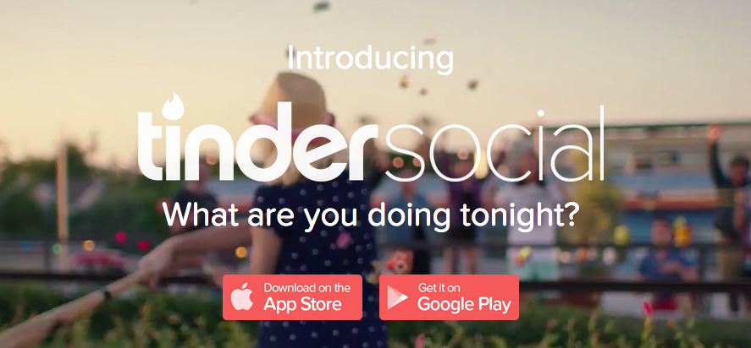

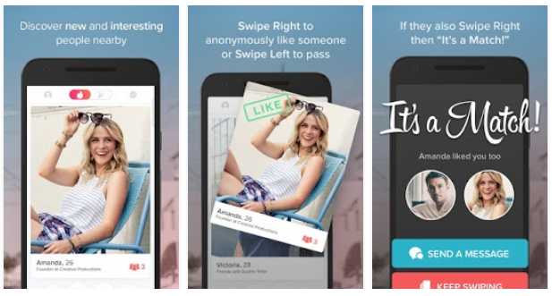

Tinder is a dating app that is used to match between two users who has signed up on the application depending on their profile entries a location. on other words, Tinder can be explained as a location-based social application that can be registered in using Facebook profile and then Tinder algorithms facilitate the best match for each interested user. and whenever two users have matched and both have accepted to match the application allow both to access a chatting area which allows them to swap interests or meet. Lately, Tinder is being used as a general social media application and more functionality have been implemented on the application in order to attract more users such as:

* Tinder trends: So Tinder has added this function which allows users to follow influencers on the app such as celebrities and many others so a normal user can keep an eye on their beloved influencers knowing about their new posts and watching their photos.
* Tinder share: This new function allows Tinder users to share music that they like with other matching people through Spotify. *(Tinder - meet interesting people nearby, 2016)*

1. Alternion:

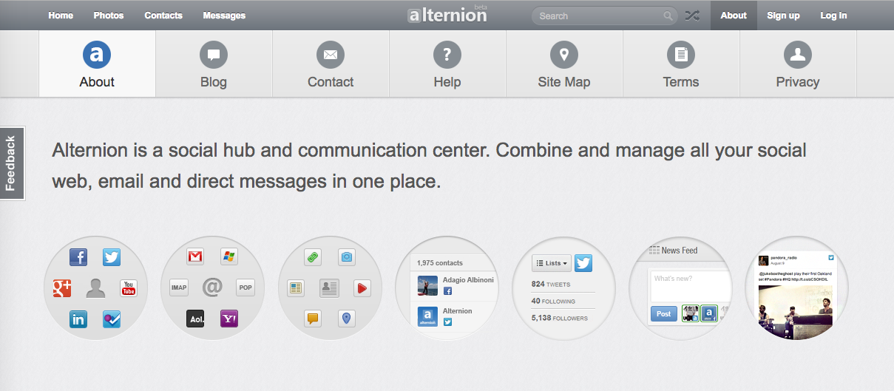

On the news sides, there many apps in the market that usually specifically used to request permissions to access all your social media accounts, and then it will take all posts from all the accounts and show it on one page. So user wouldn’t spend long time going from one app to the another in order to read posts and the stuff in the app. one of the most used applications for such functions is Alternion. Alternion gathers all posts and feeds from all social media network and post it to your page on their website. and those posts would keep updating all the time and what makes it really interesting on Alternion supports more than 220 social networks !! AS well as, it can support gathering information and emails from your Hotmail, Gmail or Yahoo on the same time and show it as social aggregating system.

the two functions that Alternion use that make me interested in searching more details about would be that it covers almost the same idea of Let's unite app. The news feeds in Let's Unite app would take the news from a specific social media networks and then it can be all viewed in one page after applying filtering to each post. Alternion offers users to control their filtering system on the app and their privacy control on the application. *(Alternion, 2013)*

1. Eventbrite:

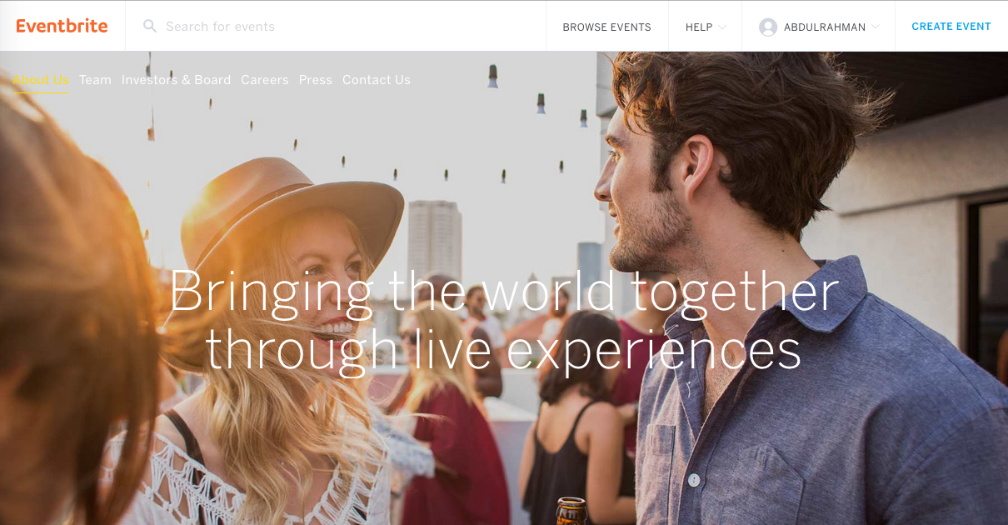

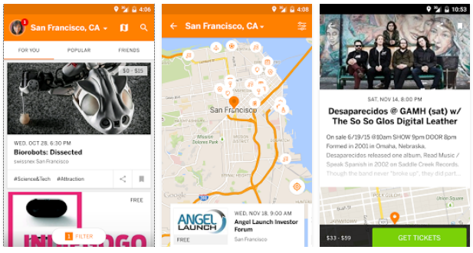

Searching the events applications and apps make adding the requirements of the app subject to change when seeing different technologies and platforms. Going through few of the events organizing apps and websites such as EventBase application, whova application and many others. Every application has different idea in the way of managing a specific event.

One of the most interesting application and it is classified as the most popular application is Eventbrite. By using very simple way of issuing tickets it has gather a huge number of users. Eventbrite has four simple steps in order to create and organise any event. Starting with creating a page for an event by adding photos, summary, explanation and location of the event. The applications request from the user who has created the event to give them details such as bank details and so on. After that, it allows the event organiser to share this event easily in many social media or sending by email to list of people. It simply helps the event organiser to spread the event to a specific group of people. Whenever users are interested to attend the event, they either if they have existing accounts would register and pay for this event in two steps or they need to fill some information about them self and fill their credit card details in order to pay for the ticket. In the last year or two, Eventbrite has implemented a new function which allows the event organizers to check-in tickets for audience using the camera of the phone using the technology of image processing in order to add such as an amazing handy function. Eventbrite used to send their own products to help big events to check-in on the event day. However, after implementing this function they have reduce the amount of spending on those products hugely. *(Eventbrite, 2016)*

1. Meetup:

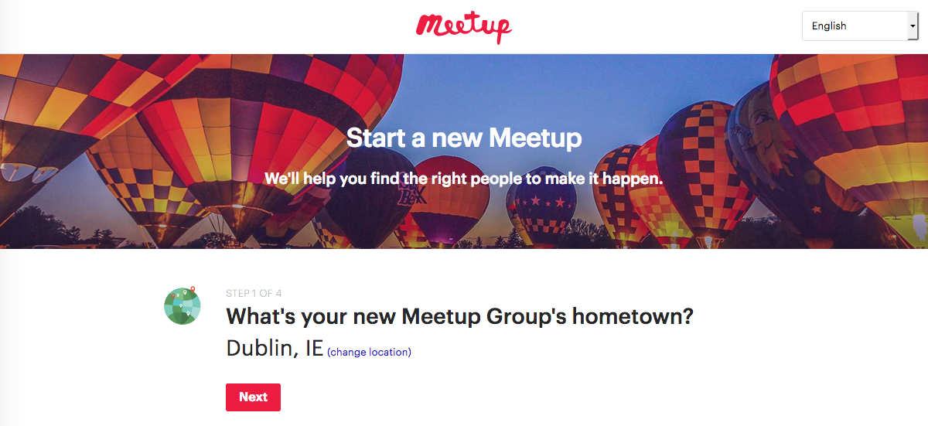

Discussing depending on what we should divide groups in Let's Unite application is kind of need heavy thinking. Meetup application has a great idea to solve such problem. Meetup brings groups of people depending on two main important points. Starting with checking their location and where they are based. It doesn’t really go any deeper than checking in which city the user base. The second point is to check the user interests. For example if user interested in cooking food so all the events that has any relation to cooking food would show for that specific user. In general the application doesn’t do much with location except checking which city the user in and whenever user create a new event or meeting the location can be shared with everyone else. The number of categories in Meetup is amazing as the application has all the following categories:

* Tech Meetup groups
* Moms Meetup groups
* Dads Meetup groups
* Fitness Meetup groups
* Hiking Meetup groups
* Career and Networking Meetup groups
* Support Meetup groups
* Book Club Meetup groups
* Photography Meetup groups
* New in Town Meetup groups
* Social Meetup groups
* Dog Meetup groups
* Language Meetup groups

*(Meetup, 2016)*

1. Find my phone Applications:

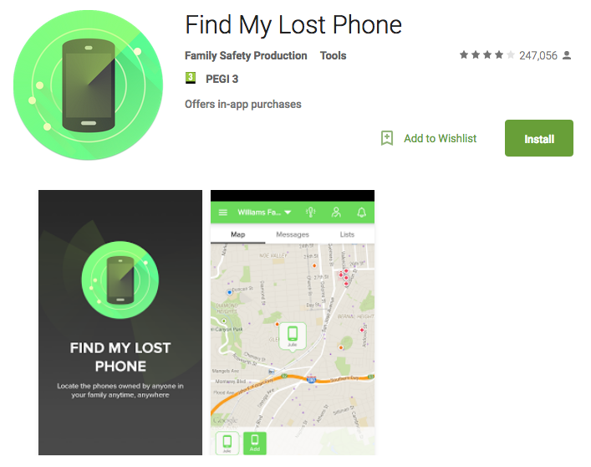

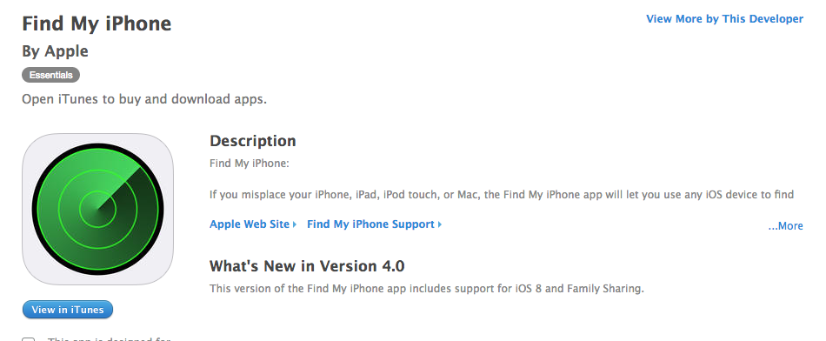

Most of the applications that is used to find a lost or stolen phone work almost in the same way. The way these application work, whenever is the owner of the phone has lost the phone in any way the user can go straight to the browser and enter the account details for the user’s phone and then the web application will detect the location of the last time the phone was connected to the internet. so in the cases if the phone is lost that last location of the phone that would give an idea to the user where the phone was left the last time. And if the phone was stolen, reporting where the phone was online the last time might give an idea to the inspectors to check monitors or CCTV cameras in order to see who has stolen the phone, or in some cases the lifters might forget to turn the phone off. The idea of bringing up find my phone applications is that, the functionality of finding the phone is almost the same idea of the functionality for the project.

The algorithm of finding phone application works is by installing the application in the phone, using state-of-the-art GPS technology. By giving permissions to the application to access the location feature in the phone. The application in the phone will keep sending the coordinator of the phone to the server of these applications and whenever the user wants to check their phones, they need to login into the application website. there will be a map that showing the location of the phone. *(Tools, 2016)*

## Technologies Researched

1. Application Development (Android, IOS and Windows)
   1. Android:



Android software development is a process to build a mobile application that is specially created to be working for any devices that is running by Android operating system. All Android are implemented using Java programming language as well as software development kit (SDK) from Android. The Android SDK has many sample project that can be started with source code of each as well as development tools, emulator and libraries to implement any Android application. Java programming language run on Dalvik which is a virtual that runs the implemented applications and any code written in Java. Although, Dalvik is a specially designed virtual machine for embedded use which use on the top of a Linux-kernel. *(What is Android SDK? Webopedia definition, no date).*

Many other environments that are available in order to implement an Android application. As well as new platforms such as Ionic can be used as it uses a language wit Cordova in order to translate it to the native language. Such platforms are helpful when deciding to implement the same application for many operating systems in the same time. Those platforms will reduce the amount of time that is used to implement the application hugely.

Android operating system is the most and highest selling mobile operating system in the world. The statistics show that over one billion users in the world are using android phones and tablets. As Android is open source operating system, that gives a huge advantage in the market as it allows any company or developer to install the operating system and justify on the way that it is required. On the other hand, anyone can develop an android application having all the support and environment that would help to develop any such application with the huge amount of resource that available online. As mentioned above the number of android users is massive. On the same time, the number of users has increased dramatically on the developing countries.

One of most important advantages for android is the review process for application in order to be uploaded to Google play is simple and takes a lot less time than other operating systems. Another thing that makes Android popular is the amount of free applications that available in store ad cab downloaded easily including games and many others. the support for both software and application is just perfect. On the same time, the number of option to buy an android phone is huge, there is an option to get a smartphone with an android operating system in any budget limit that the user is looking for.

Thinking of the negative side of developing an android application can make the decision harder for the developer to decide whether to choose Android or other systems. Staring with big number of different screen sizes and resolution which effect the developer on the way that implementing their applications in the way that the application size and user interfaces.

As mentioned in the advantages section of Android, the result of having the applications review system is fast in Google play that cause many applications contain viruses easy to be uploaded in the market which lower the security in Android operating system. As well as, the number of free applications in the market is huge. However, that will consequently to always have Ads on display of the applications. *(Soffar, 2015)*

* 1. IOS:



IOS is an operating system that is only used to work for apple products and it is implemented and designed by apple company its self. In order to implement any application for apple that application would not be any useful for any other phones other than Apple. So all the software’s are exclusively for its hardware. This is not only for the iPhone, it would be working with other products iPad, iPod and apple watch on the same time. While Apple is monopolising their product to their software it is still the second most popular mobile operating after Android World-wide. *(Warren, 2013) & (Inc, 2016)*

To develop an IOS application the developer is required to have Mac Machine that runs OS X for it. There is no way that developer can implement an IOS applications using Microsoft or any other operating systems. So Xcode is the official Integrated Development Environment for IOS. which has all the development requirements environment for developers such as Compiler, Interface builder, Simulator, Frameworks, and Full documentation reference library. all mentioned environment is offered free of cost by apple and it is available in the apple store.

All IOS applications are written in Objective-C programming language in the start of IOS system in 2008. Objective-C is known as objected oriented language that is bases on C programming language. So, it uses the simple C programming language with the powerful function of the object oriented language functions and coding style in general such as using classes and methods. Object oriented programming languages make it easier to develop structured and maintainable code. In 2014, apple has decided to announce Swift programming language. Announcing a new language was a challenge that apple has made for developers as they need to learn a new programming language syntax. However, Swift has gained a huge positive reputation very fast for many reasons. Swift has removes all the unsafe pointer management. On the same time, it has introduced a very strong powerful features while improving and supporting the use of Objective-C. Since 2014, Swift is already strong development platforms and very popular. *(Burojević, no date)& (Mustapic, 2010)*

To implement an IOS user interface, Xcode offers to use the interface build editor within Xcode. In simple way developer can design their applications using this amazing and easy to use tool. which allow them to design the full application without the need to write any code. Using drag and drop windows, tabs, buttons, text fields and many other functioning objects for the user interface. As Cocoa and Cocoa Touch were built using Model-View-Controller pattern, it makes it a lot easy to implement the design of the interface independently from the implementation of the code. *(Inc, 2016)*

There many advantages developing an IOS application that make IOS system the second most popular operating system world-wide. It is well known that IOS has great performance and Apple devices are high quality when comparing to many other products as it generates less heating and a lot faster. Apple store contains a huge number of applications including amazing gaming experience. IOS is more attractive and preferable than other operating systems because it suits business and gamers. As well as, IOS has excellent user interface and fluid responsive. Although it simple and easy to use. Apple has flow a policy that focus in making their products unique and make the user feel awesome when using it. especially when apple has introduced the wearable devices such as apple watch. Finally, IOS is well known as a very secure system.

On the other hand, many developers believe there are many disadvantages using IOS system. Starting with the flexibility of IOS application, as it only supports IOS devices. So any application that is implemented for IOS it has to be designed for Apple devices. On the same time IOS operating system is not open source. That makes all updates and edits to the system is done by Apple itself and their developers. Mentioning costs, apple devices are costly and many applications on the apple store is costly. Lastly, the review system of apple store is hard to get through as it takes long time to get an application approved to apple store. Which it has two views, the first one is that testing an application and make it available on the market costs very long time which developers do not like. the second view explains the high security of IOS by mentioning that no application is approved until it is fully checked and approved by apple developers. *(Nield, 2015)*

* 1. Windows:

Windows phone is an operating system that is a member of Microsoft operating system family. Windows phone was developed to support smartphone and tablet needs by Microsoft and as a main alternative to windows mobile and Zune. As the smartphones and tablet market has increased dramatically Microsoft needed to follow up by implementing an operating system with many features such as a new user interface which was firstly lunched in windows phone 7 in October 2010. And then followed by windows 8.1 released to manufacturing on April 14, 2014.

To develop windows phone application there are requirements starting installing visual studio which is the development environment from Microsoft. Visual studio was created by Microsoft to develop any programs for Microsoft and windows. As well as it supports to develop web sites and web applications. After that it is required for implementing an application for windows phone to install windows phone SDK. Creating a new project for windows phones that require the use C/C++, C# or visual basics templates.

Windows phone has an advantage of their design, It uses a very colourful icons that make the system more attractive comparing to other operating systems such as android. The design of windows phone looks completely different form IOS and Android as in many researchers say that it is more distinctive. There is a huge negative side of windows phone which the small number of user base. This negative has effected many the number of applications that exist in Microsoft market, simply there are not enough applications in the market for windows phones. on the other hand, all the big services have applications for windows phones such as Facebook, twitter and snapchat. As an advantage Microsoft has tried to sort such problem by making fairly easy for developers to port their IOS applications to windows phones. *(Home, 2016)*

Windows phone has a great reputation about their phone performance as it is well known most of windows phones are fast. However, that does not give Microsoft an advantage as most users in the world look always for fancy phone with new features to attract them. Going over so many feedbacks about windows phones, most user say Microsoft make perfect product but with much less features than their competitors.

1. Server Implementation (Python, PHP, Java and .NET)
   1. Python:

Python is an Object oriented, interrupted and high-level programming language. it is amazingly high-level in built in data structure, combined with dynamic typing and dynamic binding. Which makes more popular, Python is simple, easy to use and easy to learn it's syntax. Python encourages program modularity and code reuse by supports modules and packages. As well as, Python is open source and all its standards libraries are available in binary or source form without any charges for mostly all platforms.

Python has an advantage as it is easy accessible language for programmers as the community offer many introductory resources. And has another advantage which is used mostly in universities to be thought when using friendly devices such as the Raspberry Pi*. (Makai, 2016)*

In 2016 IEEE ranked python as the top third programming language, such ranking show how roughly is the language popular. such ranking does not show how many programmers are using this specific language. However, it gives he aggregate view that python stays a stable programming language.

Python flask is a micro framework primarily aimed at small applications with simple requirements based on two external libraries; Jinja2 template engine and the Werkzeug WSGI toolkit. The main reason to choose python flask was based on how easy it is to learn and to use; it basically helps to build a web app in a short time. Although, it is a small and powerful web framework for Python using Flask-Restful as an extension for Flask to support for quickly building REST APIs that uses HTTP requests to GET, PUT, POST and DELETE data. This project needed to post data from the Arduino sensors and the get those data to the server, as well as to post data to the mobile application. *(Welcome to python.org, 2001)*

* 1. PHP:

PHP is used as a server side programming language, and it was primarily designed for web development. However, PHP also used as a general programming language. PHP is very popular because of many reasons, starting with how powerful, deep and easy is the language as it runs one of the largest social network which is Facebook. As well as, it is usually taught for beginners to program a simple server.

There many advantages that help any programmer to use PHP as their programming language. Starting with that PHP can run on almost all platforms such as Windows, Linux and Mac OS. Although, PHP is compatible with various servers used today such as Apache and IIS. On the same time, PHP supports most of the databases that exists. As well as, PHP is free to download and use and it can be down from the official PHP source*. (Group, 2001)*

* 1. Java:

Java is one of most used programming languages and computing platforms. It was lunched at first in 1995 by Sun Microsystems. Java is mostly used everywhere starting with Web Apps, Mobile Apps (As mentioned above in Android studio), IOT, Machine learning, cloud services and many others. On other words, Java is a programming language that is designed for use in distributed environment. As Java is an object oriented programming language comparing it to C++ it is simpler and enforces an object-oriented programming model. it can be used to build both complicated and small applications or it can be use as part of web pages.

There are significant advantages when a developer thinks to use Java as the main programing language over other languages in any idea or programming task. Java is very easy to learn language and it was designed to be this way which makes on the same time, has a simple syntax to write, debug, compile and learn when comparing to other object oriented languages. Another advantage of Java is its ability to be moved from one system to another and its ability to run the same program on many different systems. it can be used to run on a single machine to a world-wide software as Java's platform is independent at both sides source and binary level. *(IBM knowledge center, no date)*

* 1. .NET:

.NET framework is not a programming language; it can be explained as a software framework that was implemented by Microsoft to be run mainly on Microsoft windows. .NET platform is a development framework that help developers to creating windows applications and provides a new way to create applications and web applications in very easy and fast way. .NET has a huge number of class libraries known as (FCL) which means Framework Class Library. And Which makes very unique that .NET provides language interoperability which is basically allow each language to use other code that is written in a different language with many different programming languages.

.NET is the newest technology that implemented by Microsoft for app development. It has an amazing IDE and it is fully integrated. As it is designed specifically by Microsoft, it is still support by Linux and Mac by a third party which is Mono. Another advantage of .NET which it has many languages available such ad dynamic, static and functional. *(Microsoft, 2016)*

1. Databases:
   1. MySQL:

MySQL is defined as the most popular Open Source SQL database management system and it is developed, distributed, and supported by Oracle Corporation. *MySQL 5.7 reference manual (2016).* A database is a structured collection of data. It may be anything from a simple shopping list to a picture gallery or the vast amounts of information in a corporate network. To add, access, and process data stored in a computer database, a database management system such as MySQL Server is needed. Since computers are very good at handling large amounts of data, database management systems play a central role in computing, as standalone utilities, or as parts of other applications.

In this project, the data storage technology was used in a simple way to store the data that were collected in a simple table on the server. Each event was stored as tuple of temp, sound and event time stamp. *(MySQL: MySQL 5.7 reference manual: 1.3.1 what is MySQL?, 2016)*

1. Cloud Services.
   1. Microsoft Azure:

It is a cloud computing service that used to manage different application and services through the Internet. It is used as server to be programmed and set up using different programming languages, tools and frameworks, in order to reach the specific goals that is implemented for. It is created by Microsoft and it provides both PaaS and IaaS services including both Microsoft-specific and third-party software and systems.

* 1. Amazon:

Amazon has many cloud services such as EC2 and AWS. Amazon Web Services (AWS) is one of the common use cloud services platforms that is used. AWS is a secure service that offers computer power, databases and many other functionalities which is used for business and user to scale their growing. Amazon web services which known as cloud computing now days has many advantages which make it a very good option to choose. That is clear as amazon has improved flexibility, scalability and reliability. As well as, from the cost side Amazon consider as low cost cloud service as business need to pay-as-you-go for the services that is only used. Another advantage of amazon AWS has a very good agility and instant elasticity, as Amazon offers a massive global cloud infrastructure. With such infrastructure businesses and users do not need to wait long time in order to receive their hardware and set it up. *(About AWS, 2016)*

1. Location & distance:

Technique 1:

The first technique to calculate the distance between two pints would be using math. Using a calculation for latitude and longitude points applying a specific formula in order to find the distance between two points. This formula was implemented on the basis of spherical earth which would give a very accurate results. The very small error occurs as the earth is very slightly ellipsoidal. To apply this formula which is called ‘haversine’ what is simply calculate the circle distance between two points finding the shortest distance over the earths surface, ignoring hills and peaks.

The ‘haversine’ formula represented as the flowing:

a = sin²(Δφ/2) + cos φ1 ⋅ cos φ2 ⋅ sin²(Δλ/2)  
c = 2 ⋅ atan2( √a, √(1−a) )  
d = R ⋅ c

where φ is latitude, λ is longitude, R is earth’s radius.

The haversine formula is particularly well conditioned for calculating the distance between two points, and it works quite well for even at small distance unlike calcula­tions based on the spherical law of cosines. *(Veness, 2002)*

After applying haversine formula to the coordinators between the user who is looking for people to meet up with, and other checked in coordinators the algorithm can be improved to specify a maximum distance checking e.g. 10 Km and many handlers as checking if they are both doing the same course or not. Furthermore, if users match with all requirements a notification can be send to both sharing locations with each other.

Technique 2: Google Distance Matrix API

Google Distance Matrix API is using almost the same idea above. which is defined according to google developer website as a service that return travel distance and time which available and it can be used as part of the client-side Google Maps JavaScript API, or for server-side use with the Java Client, Python Client, Go Client and Node.js.

Considering the following possible issues if using the above solution:

1. If application keep on sending user's location then the user battery will be getting down, and web server memory will increase.
2. Application will keep on use internet to send location to web server.
3. At the time of roaming internet data cost may increase.

Helpful hints in order to sort the issues above:

1. The app should send the user's location every 15 minutes.
2. Every application should use unique id to update their location.
3. If application closed, then clear that app's location in web server. *(Find nearby users of an app (iPhone and Android), 2016)*

Technique 3:

The Google Maps Geolocation API

The second method using Google developer’s APIs that uses Maps Geolocation to return a location and accuracy radius taking information from the cell towers that the phone is connected to as well as the Wi-Fi nodes. So whenever the user is connected to the Wi-Fi or cell, tower the information can be retrieved depending on their connection. All these APIs communication is implemented over HTTPS using POST. And requests and responds are in JSON format. whenever the geolocation request is done and worked it will return a JSON-formatted response with details about a location and radius. *(The Google maps Geolocation API, 2016)*

Talking about google APIs, it has a huge number of solutions that would make an absolute great functioning app. Adding Nearby Connections API which allows user to discover other devices on the same local network as well as allows them to connect and exchange in real-time chatting. Although, it gives many capabilities to app such as Collaborative whiteboard, Local multiplayer gaming and Multi-screen gaming. On the same time, google has nearby notification which help user to discover which around them in the map surfacing location-specific notifications. *(Overview, 2015)*

## Other Relevant Research Done

Questionnaire and Interview.

1. Questionnaire:

On this part of the research, focusing the stockholder of the system is really important. Starting with a questionnaire (survey) that can be send to a number of students explaining the idea of the system in a very general picture and then the question will be about getting a general feedback from the students about how they imagine the system and what other functionalities or tools can be added to the project in order to reach the best satisfaction.

Using a questionnaire has many advantages, like many evaluation methods occur after the event, so participants may forget important issues. However, questionnaires are standardized, so it is not possible to explain any points in the questions that participants could misinterpret. This might be partially solved by piloting the questions on a small group of parents or at least friends and colleagues. It is advisable to do this anyway. As well as, open-ended questions may generate large amounts of data that would take a long time to process and analyse. One way of limiting this would be to limit the space available to parents, so their responses are concise or to sample the students and survey only a portion of them. It is important that when implementing this method to know that respondents may answer superficially, especially if the questionnaire takes long time to complete. The common mistake of asking too many questions should be avoided. *(Learning, 2009)*

In order to reach the highest possible number of responds, a decision was made to implement the survey using two languages, English and Arabic. Such decision will help to make the survey to be filled with almost a double of the expecting number as well as the background culture can be very important to make the project suitable for the bigger number of people from different backgrounds.

Introduction to the survey; Have you started college this year?

Have you moved to new country to study?

Do you find it hard to meet new people in your college?

Are your kind of person who is very social and like to meet new people?

Do you think of having a specific social application for your work, organisation or union?

Think about a mobile application that allows you to create an account, specifying which course you are doing in your college. this application will look for friend nearby you and whenever you are bored or you would like to meet with new friends in your college, all you need is simply press I’m bored button on the application and then it will show all the friends nearby you and send them notification asking them to join you wherever is your location. On the same time this application will gather all the news and events about your college from social media and put all in one tab for you.

هل بدأت الدراسة في الجامعة هذا العام؟

هل انتقلت للعيش في بلد آخر للدراسة؟

هل تجد من الصعب لقاء أصحاب في الجامعة او التعرف على الاخرين في محيطك الجامعي؟

هل انت شخص اجتماعي وترغب في لقاء ناس جدد دائماً؟

هل تفكر في وسيلة تواصل خاصة بينك وبين زملائك في العمل، المنظمة التي تنتمي إليها؟

تخيل وجود تطبيق خاص في جوالك تستطيع من خلاله تسجيل معلومات أولية عنك مثل التخصص الجامعي الخاص بك او ما إلى ذلك. بأي وقت تشعر بالملل او ترغب في لقاء أناس جدد من محيط جامعتك او عملك كل ما عليك فعله هو الضغط على زر الملل. سيقوم التطبيق بالبحث عمن يتواجد بمقربة من الموقع الذي تتواجد به.. بعد ذلك سيقوم التطبيق بإرسال اشعار لكل من هم حولك بوجودك بموقع محدد. بالإضافة إلى ان التطبيق سيسهل عليك الكثير حيث سيقوم بجمع كل الاخبار عن (مثال جامعتك) ووضعها في لك في التطبيق حيث يكون بسهولة معرفة الاخبار وما يحصل بمحيط الجامعة وكذلك الانشطة والاحتفالات حيث يعتمد التطبيق على مشاركة موقعك مع الأصدقاء والزملاء بحال رغبتك بذلك.

* Occupation
* المهنة
* Have you ever used social media or apps to meet with new people? if yes can you specify.
* هل سبق وقمت بلقاء اشخاص تعرفت عليهم عن طريق وسائل التواصل الاجتماعي؟ إذا كان نعم اذكر الوسيلة
* how do you usually meet with new people?
* كيف بالمعتاد تقوم بلقاء اشخاص جدد؟
* Have you had hard time meeting new people when starting college?
* هل وجدت صعوبات في لقاء أناس جدد؟
* how do you set up meetings or gathering with friends or college mates?
* كيف تقوم بالتنسيق للقاء الأصدقاء او زملاء الجامعة؟
* What other functionality that you think it would help to add to such app?
* ماذا ترى ان يضاف لهذا التطبيق من وجهة نظرك
* Do you use any of the share location functionality to share your location when meeting friends?
* هل تستخدم خصية مشاركة الموقع المتوفرة في عدد من التطبيقات مثل واتس آب؟
* would you have any issue sharing your current location with other friends.
* هل لديك أي سلبيات من استخدام مشاركة الموقع في وسائل التواصل الاجتماعي
* In the scale of 10 (where 10 is Love it & 0 hate it) how would you rate the sharing functionalities in the social media.
* بإستخدام المؤشر التالي، كيف تقيم خدمة مشاركة المواقع في وسائل التواصل الاجتماعي (حيث ١٠ رائعة و ٠ سيئة جداً)

Survey was designed using google forms which has a great functionality of analysing and retrieving results. *(Google forms - create and analyze surveys, for free, no date)*

Link to survey En: <https://goo.gl/forms/qxhV3KLw3yFq9R9v2>

Link to survey Ar: <https://goo.gl/forms/AUVkPNhRVbBH2itw2>

1. Interview:

Using interview method has many advantages such as interview is useful to obtain detailed information about personal feelings, perceptions and opinions. And interview allows more detailed questions to be asked which usually helps to achieve a high response rate. In interview, the respondents' own words are recorded. As well as, ambiguities can be clarified and incomplete answers followed up and precise wording can be tailored to respondent and precise meaning of questions clarified e.g. for parents with English as a Second Language. Another important point, Interviewees are not influenced by others in the group. However, some interviewees may be less self-conscious in a one-to-one situation.

A plan was made to meet target users in order to investigate more about what others might think about such product. In this case meeting with students in college, students union representative and some other normal users would help a lot to reach the goal of gathering the required information to improve the project the best way possible. As well as, meeting with lecturers or experienced people in the market of app development would give a huge advantage to the project. As those people would think out of the box especially if they have developed many different applications in the past.

Almost the same introduction that is used in the survey can be used and as interviewer more details can be given about the application. On the same time before starting asking the guest questions, interviewer must make sure that the guest understand the full idea of the application. So an open discussion may be started in the first five minutes. After that the question should be asked.

The introduction, think about a mobile application that allows you to create an account, specifying which course you are doing in your college. this application will look for friend nearby you and whenever you are bored or you would like to meet with new friends in your college, all you need is simply press I’m bored button on the application and then it will show all the friends nearby you and send them notification asking them to join you wherever is your location. On the same time this application will gather all the news and events about your college from social media and put all in one tab for you.

* First few questions should be general about the guest to understand what is his/her life style.
  + Name.
  + Occupation.
  + Typical daily life.
* At this stage a general question should be asked about how the guest often meet with friends:
  + How do you often meet new friends?
  + How do you plan meeting with your friends?
  + How hard meeting friends?
  + Have you ever used any application or social media to meet with new friends?
* After that discussion about the project should be open with the guest:
  + What do you think about Let’s Unite app?
  + How such Apps would help people to meet each other?
  + It is kind of hard breaking ice with other class mates or colleagues, how can this be sorted?
  + What other functionality can be added in order to improve such social app?

## Resultant Findings and Requirements

As the survey has been lunched, more than 300 people has received the survey including universities students, employed people and many others using social media as main path of spreading the link such as twitter using the Saudi students’ union page as it has a good number of followers as well as personal account. On the other hand, using what’s app and Facebook groups focusing on student groups and pages in order to gather as much feedback as possible. The survey was designed to be really short in order to use this point as a marketing attractive for people to participate on this survey explaining that the whole survey can be taken in less than two minutes to be completed. As many people couldn’t understand the English survey the link with the Arabic translation has been sent to those people in order to hear their opinions about the project. Up to the time writing this part of project 56 people have completed the English survey where 31 people for the Arabic survey which gives the total of 87 responds which covers a fair enough number and it is around the number was expected. As results of both English and Arabic surveys are very close analysing the English survey would extract the same results and it would help a lot as the need of show the result for one language is simpler.

Survey:

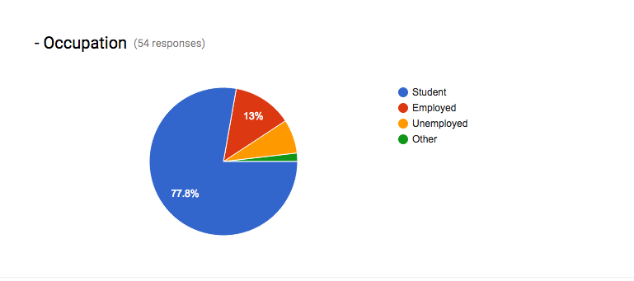

Figure 1 Survey results

The first question would give an overview about the people who participate in this survey as showing above that the number of the students who have submitted their feedback is around 48 students where the number of employed unemployed all together is less than 10 people only. In this case it helps a lot to find more about what students think about grouping social apps where experiments can be done in colleges. As well as, such numbers explain many details in the coming question where the generation would make different in giving answers.

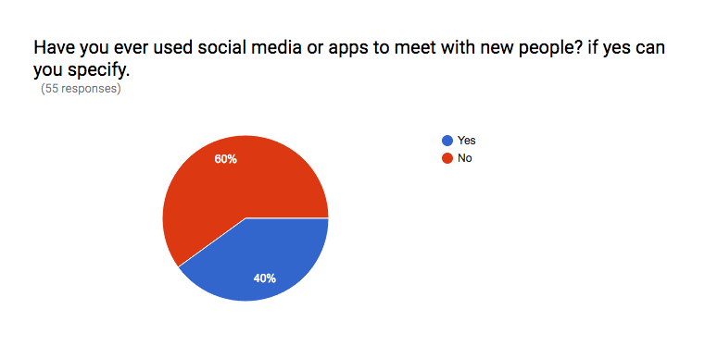

Figure 2 Survey results

At this stage a question was asked to find more details about the people background about social apps that is used specifically for meeting and grouping people. On the same time, knowing if those users would be willing to use such apps or not using their past experience. As the question has been asked using present perfect grammar so it brings to the participator mind all the apps up to the point where they were taking the survey. As well as, the question didn’t specify gender or age or the cause of the meeting so, the only goal is find if these people have ever met with new people using any social media apps. The results cam quite surprising as the percentage of people who had met new people when the question was asked is 60% out of 55 people.

This question was followed by a question to specify what apps that were used to meet new people in order to find out the cause of meetings and what technology that fit the most of the people in this survey. Surprisingly again, the results came out of expectations where the most mentioned app was Twitter which is not designed or implemented as meeting or grouping app where around 7 people out of the 60 % who take the above question as yes mentioned Twitter as the app was used to meet new people. Another good of people have specify Facebook which can be understood as Facebook has pages and groups that can be used as meeting or grouping with new people. The other people have specified different meeting or dating applications such as MeetUp, Who’s near and ShowAround which all together reach a total of 7 people.

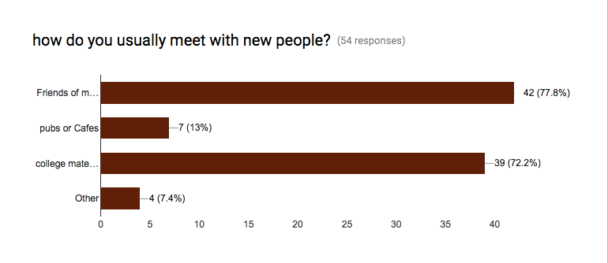

Figure 3 Survey results

Using this question in order to find out more from either who uses social apps to meet new people and who has not. Where the question was designed to use checkbox answers giving the whoever take the survey the options of friends of a friend, public places such as pubs and cafes and college mates or colleagues. The highest number of responds checked friends of friends as 42 people has specify this answer followed by 39 responds went for college mates or colleagues which clearly shows that a huge number of people are depending on a third party to meet new people which is very interesting. As it shows people need icebreaking third party in order to socialise with someone new what this project is focusing on. Furthermore, only 7 people have checked meeting new people in public places such as pubs as it brings our focus to the first question where the new generation of people are not using the old style like older generation.

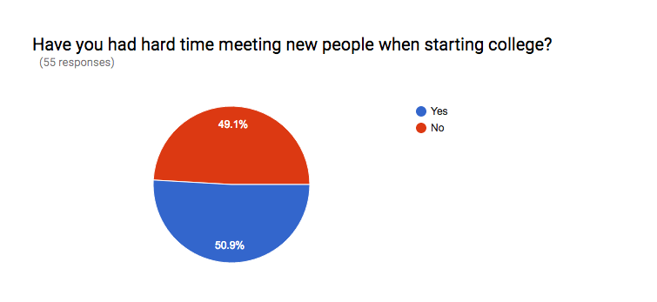

Figure 4 Survey results

Have you had hard time meeting with new people when starting college? The answer of this question almost breaks even as 50.9 % which would be around 28 of the overall number of people have took this survey answered yes. Where the survey was designed to target students in colleges, it shows the highest number of people who chose yes are foreign students as they have explained in the coming question that language and cultures are the main cause of having hard time to meet new people when asked about can you mention why have choose yes as shown below:

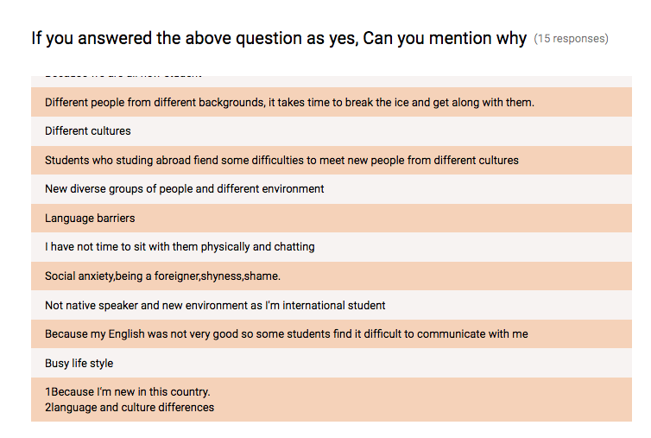

Figure 5 Survey results

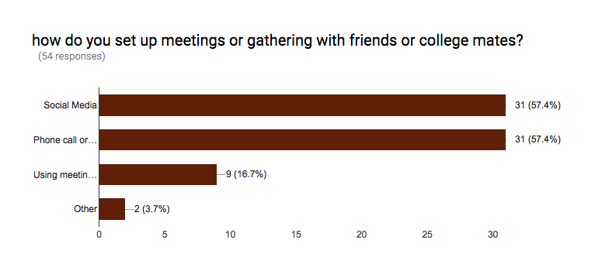

Figure 6 Survey results

the majority of people are using social media and phone calls to set up their meetings which show a huge number of dependency on the technology nowadays. On the other hand, it shows that people are more into direct contact to the person who they want to meet so that would give us a hint to implement a chatting between two people is really important. On the same time, it allows us to think out of the box where people like to do all the things that they need using one application instead of moving from one to another.

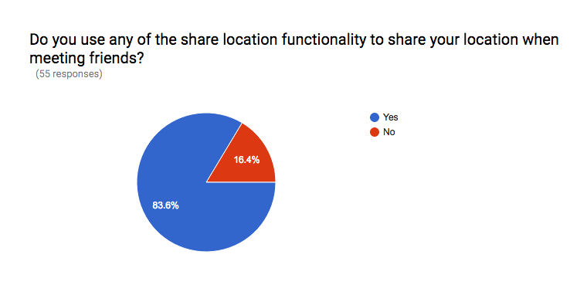

Figure 7 Survey results

sharing location with other people is very negotiable point as many experts claim that it abuses the privacy of the people. Where other claims it is not a big matter with the huge grow of technology. And as sharing the location is the most important functionality in this project. A few questions were asked to the people in order to investigate more details if they would be interested in sharing location with friends and with people that they are going to meet. Starting with the question if they use such functionality often. And the percentage of the people who use sharing location functionality is really high as shown in the graph above. Around 46 people overall responded to this question as they do share location which as well bring us back again to the first question where the generation matters.

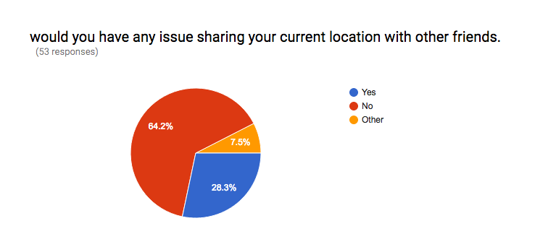

Figure 8 Survey results

In order to retrieve more accurate information, the question was asked on a different way using the negative and more direct as if they have a problem sharing location with friends, as shown in the graph above, the percentage has decreased slightly where 64.2 % of the people claimed that they would have no issues sharing their locations with others. Furthermore, when the question asked directly some people would take the matter of privacy a little more carefully as just about 15% of the people have changed their mind.

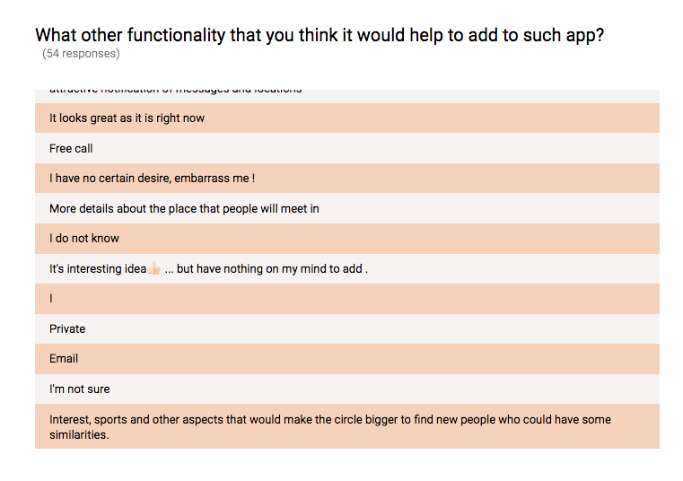

Figure 9 Survey results

Many of the questions that required writing in surveys are not usually accurate. Often people wouldn’t think about what to write or to add. However, it shows a very interesting part about their general view. In above question a direct question was asked about what other functionalities can be added to this project. As mentioned above, an interesting part that some people explained their thoughts about the app. Some asked to asked to add free calls as they might think it a dating app to allow communication between people before they meet. Some others think it is a good idea and it should be implemented as it is. Where some minority linked the idea of the project with an existent app online such MeetUp as they requested to circle the way people meets depending on their interests like sports.

The interesting part is that many of the quite interesting suggestions came from the Arabic survey. One of the responds requested to specify the gender that they are interested in meeting where he culture side is shown strongly here. Another interesting suggestion was to show recommendations to the user of the application whenever they felt bored by tracking their mode by showing a menu after bored button is pressed. Another respond suggested to share photos of the current location where the user want to meet people around. As shown in the graph below:

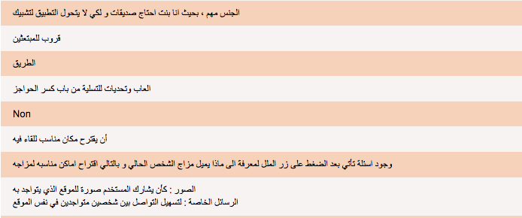

Figure 10 Survey results

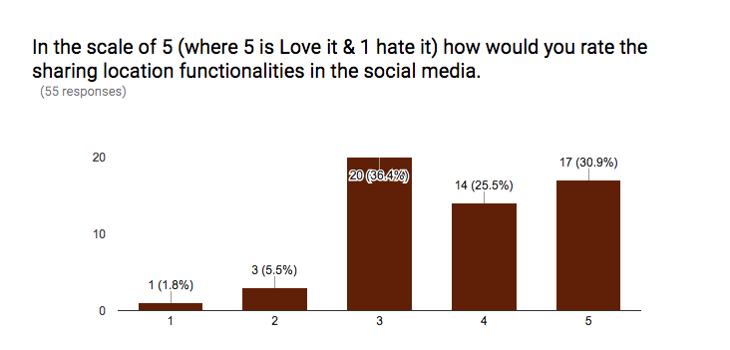

Figure 11 Survey results

The last question was asked to figure out a conclusion out of the people who has participated in the survey asking them to rank sharing location functionality in social media in general. So not to specify any app to give a wider range of thinking. Many would have thought about Facebook where some others might think about what’s app and so on. 20 people has chosen number 3 which is the middle and they would be the majority. It is fair choice as on the most general questions some people would take it as just to be fair. What is really good that 31% of the people have picked the positive side of the scale option number 4 and number 5 where 5 is love sharing location in social media.

**🡺 Interview Findings to add 🡸**

## Bibliography

* *Tinder - meet interesting people nearby* (no date) Available at: https://www.gotinder.com/ (Accessed: 1 November 2016).
* Alternion (2013) *Your social hub*. Available at: http://www.alternion.com/ (Accessed: 2 November 2016).
* Eventbrite (2016) *Eventbrite*. Available at: https://www.eventbrite.ie/ (Accessed: 2 November 2016).
* Meetup (2016) *We are what we do*. Available at: https://www.meetup.com/ (Accessed: 2 November 2016).
* Tools, F.S.P. (2016) *Find my lost phone - Android Apps on Google play*. Available at: https://play.google.com/store/apps/details?id=com.fsp.android.phonetracker&hl=en (Accessed: 4 November 2016).
* *What is Android SDK? Webopedia definition* (no date) Available at: http://www.webopedia.com/TERM/A/Android_SDK.html (Accessed: 4 November 2016).
* Soffar, H. (2015) *The advantages and disadvantages of Android mobile phones | science online*. Available at: http://www.online-sciences.com/technology/the-advantages-and-disadvantages-of-android-mobile-phones-2/ (Accessed: 4 November 2016).
* Warren, R. (2013) *Creating iOS apps: Develop and design*. 2nd edn. San Francisco, CA: Peachpit Press Publications.
* Inc, A. (2016) *Introducing touch bar*. Available at: https://developer.apple.com/ (Accessed: 27 October 2016).
* Burojević, V. (no date) *Becoming an iOS developer*. Available at: https://infinum.co/the-capsized-eight/articles/becoming-an-ios-developer (Accessed: 27 October 2016).
* Mustapic, M. (2010) *An iOS developer’s guide: From objective-c to learning swift*. Available at: https://www.toptal.com/swift/from-objective-c-to-swift (Accessed: 27 October 2016).
* Inc, A. (2016) *Xcode*. Available at: https://developer.apple.com/xcode/interface-builder/ (Accessed: 27 October 2016).
* Nield, D. (2015) *IOS vs Android: The 2015 edition*. Available at: http://fieldguide.gizmodo.com/ios-vs-android-the-2015-edition-1700461435 (Accessed: 27 October 2016).
* Home (2016) *Windows phone vs Android - an in depth comparison*. Available at: https://3g.co.uk/news/windows-phone-8-1-vs-android-kitkat (Accessed: 1 November 2016).
* Makai, M. (2016) *Why use python?* Available at: https://www.fullstackpython.com/why-use-python.html (Accessed: 5 November 2016).
* *Welcome to python.org* (2001) Available at: https://www.python.org/doc/essays/blurb/ (Accessed: 6 November 2016).
* Group, T.P. (2001) *What is PHP?* Available at: http://php.net/manual/en/intro-whatis.php (Accessed: 7 November 2016).
* *IBM knowledge center* (no date) Available at: http://www.ibm.com/support/knowledgecenter (Accessed: 8 November 2016).
* Microsoft (2016) *C# and .NET programming*. Available at: https://msdn.microsoft.com/en-us/library/orm-9780596521066-01-01.aspx (Accessed: 8 November 2016).
* *MySQL: MySQL 5.7 reference manual: 1.3.1 what is MySQL?* (2016) Available at: https://dev.mysql.com/doc/refman/5.7/en/what-is-mysql.html (Accessed: 10 November 2016).
* *About AWS* (2016) Available at: https://aws.amazon.com/about-aws/ (Accessed: 1 November 2016).
* *haversine formula in JavaScript*. Available at: http://www.movable-type.co.uk/scripts/latlong.html (Accessed: 4 November 2016).
* Veness, C. (2002) *Calculate distance and bearing between two latitude/longitude points using*
* *Find nearby users of an app (iPhone and Android)* (2016) Available at: http://stackoverflow.com/questions/7848093/find-nearby-users-of-an-app-iphone-and-android (Accessed: 12 November 2016).
* *The Google maps Geolocation API* (2016) Available at: https://developers.google.com/maps/documentation/geolocation/intro (Accessed: 11 November 2016).
* *Overview* (2015) Available at: https://developers.google.com/nearby/connections/overview (Accessed: 12 November 2016).
* Learning, I. of L. (2009) *9. The advantages and disadvantages of questionnaires*. Available at: http://libweb.surrey.ac.uk/library/skills/Introduction%20to%20Research%20and%20Managing%20Information%20Leicester/page_51.htm (Accessed: 25 October 2016).
* *Google forms - create and analyze surveys, for free* (no date) Available at: https://docs.google.com/forms/u/0/ (Accessed: 29 October 2016).
* Leffingwell, D. and Widrig, D. (2010) *Agile software requirements: Lean requirements practices for teams, programs, and the enterprise (agile software development series)*. 4th edn. Boston, MA: Addison-Wesley Educational Publishers.

# Description of Solution

Mobile Application; To make this idea comes to reality, the need of designing a very clear, simple, simple and easy to use graphical user interface. This step can be achieved be developing an application with a design that can follow these important steps. The mobile application will be implemented for Android platform using Android studio. The application will have a simple menu that the user cannot access this menu until the registration has been completed. After that user is required to login and redirect to the menu. The menu has few tabs such as meet friends, news, events, manage my account and I’m bored button. Each tab has its own functionality.

The login functionality will have required the user to sign up for using the application. Normal details will be gathered from the user such as name, email contact details and the organisation that the user belong to. The organisation should be implemented as a drop down menu. Whenever user has completed their registration, their data will be stored in the database that is implemented on the server. Whenever the user is logged in all their profile will be depending on their id to track their coordinators and show the relevant news using intent.

Meet friends tab will show the user friends or college mates who wants to meet with new people so this tab can be shown as a map or list of names. User can press on specific people to find out more about them such current location, names and contact details.

In the news button, a list of tweets can be viewed by the user that would show news about their college or the events that is happening around them. Gathering these tweets from specific hashtags in twitter going through a filter engine in the server and then displayed in the user profile.

Event tabs can contain different details about the most common events in the organisation. Either link to events with summary about the event is added or the admin can create event to allow users to join this event by pressing attend the event. So the admin user can create, delete and update events where simple user can only view the event and register for this specific event.

Users will be allowed to update their accounts by going to manage my account tab. Simply, users can update their information. Furthermore, users can press I’m bored button to allow nearby users where is the current location of the bored user in order to join him/her. By pressing I’m bored the current coordinators of the user is detected and being processed and send to the location engine in the server.

Server; the server will be configured and implemented using python programming language and python flask. The server will have both the location engine and filtering engine. The location engine main functionality is to get a user coordinators and then compare it all other users according to the radius between the user coordinators and others who is logged in and looking for someone to meet. Whenever the engine has detected coordinators nearby, it will push a notification to the user requesting to join the bored user. And the engine should return no friends has been found. And maybe find a way to send the user all the events are happening around them instead so they can go and enjoy their time.

The filtering engine in the server will be implemented to detect whatever is happening in specific hashtag and gather all these tweets. Furthermore, these gathered tweets can be stored and then go through the filter system in order to detect any abusing words or inappropriate words. Whenever such words detected the tweet will be not displayed otherwise, tweets should be displayed on the news tab. Both location engine and the filtering system will communicate with application using API’s supported by python flask.

Database; The database a very important role in this application. As the need of storing all user’s details, locations and tweets as well as tables to manage the events tab in the application. The database will be set and used in the cloud services using MySQL as it is easy to use and implement and it is one of the most used databases.

# Approach and Methodology

What is your approach to this project? Are you using any particular software methodology? E.g. Are you delivering design/ code in phases, or are you completing all design up front, followed by all coding? Have you some sections lower priority if time runs short?

The term ‘Agile Methods’ has been around for 15 years, while the understanding concepts and most of the practices connected with agile software development have existed for much longer. In fact, there is still no complete agreement on what exactly agile software development is, however, agile methods certainly aim to answer the need to develop any software quickly in an environment where requirements are changing very often. The use of iterative development is common to all agile methods and usually there are frequent releases to stakeholders. Close collaboration with stakeholders is encouraged and any required changes are accepted and are part of the process. Other typical differences with a non-agile approach is the emphasis on small self-organizing teams; the idea of continuous design improvement, test-driven development and continuous integration. As well as this, knowledge management in agile development is tended to be a tactic as opposed to being based on valid comprehensive documentation, face-to-face communication being considered one of the more preferable communication means. *(Leffingwell and Widrig, 2010)*

# Design

## Technical Architecture Diagram

Insert the architecture for your solution

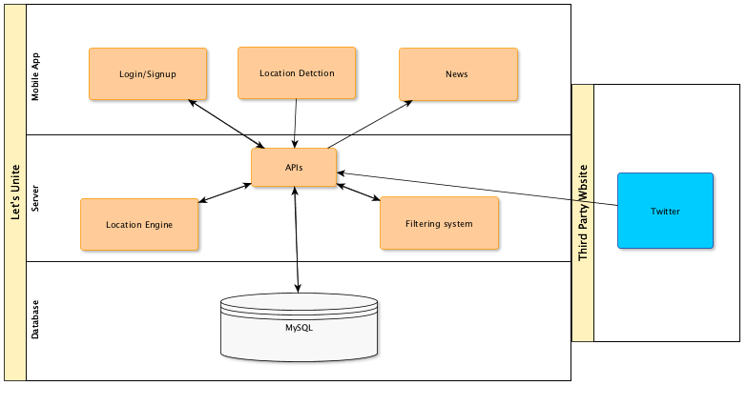

Figure 12 Technical Architecture Diagram

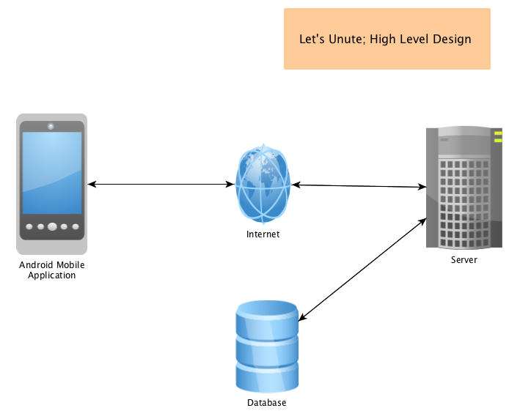

Figure 13 High Level design

## Other Design Documents

Insert other design artefacts that explain your system: e.g. Use cases/ ERDs/ Class diagrams

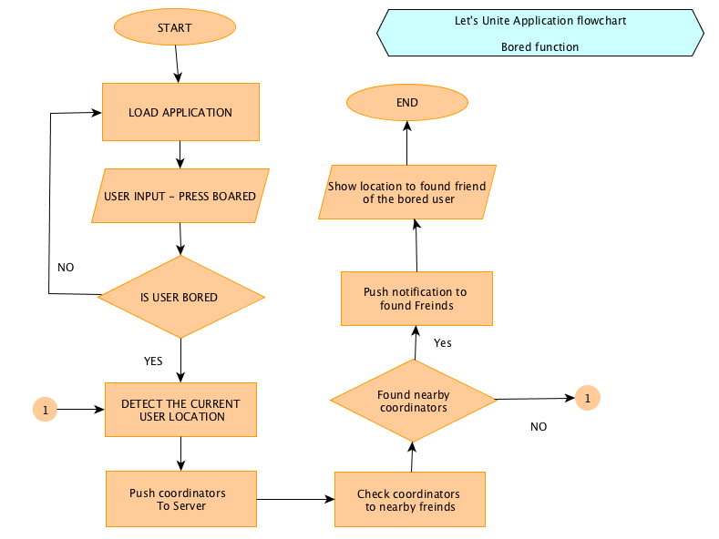

Figure 14 Flowchart 1

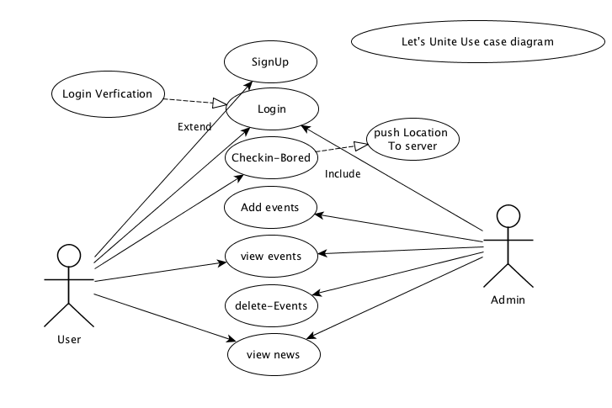

Figure 15 use case Diagram

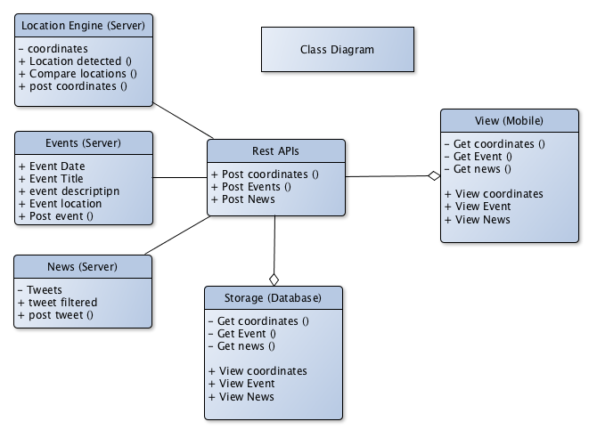

Figure 16 Class Diagram

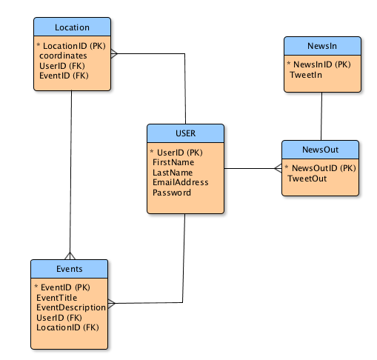

Figure 17 ERD

# Prototyping and Development

Explain exactly what prototyping and development you have completed.

# Testing

Explain your planned testing approach: For example: who will be involved, what test scripts are planned, how will the testing be executed.

User Testing:

One of the most important testing methods that can be used for such application would be user testing as it allows real user use the application in all possible way. Helping the developer to identify all the weakness points that the user has discovered as well as it helps to understand the real customers feeling about the product in general. On the same time allow the stockholders to have their time using the application to make all possible improvements that match their needs. It is basically a way of testing to get rapid user feedback on almost any user experience that possible including Mobile applications, websites and real world experience.

Unit Testing:

At a high-level, unit testing is a practice used to test the functions and areas of the system. This gives researchers the ability to verify that the functions work, as expected in the system. That is to say, that for every function given a set of inputs can check if the function is returning the correct result and will handle failures during the course of execution to a invalid input that has been provided. This will help to check if failures occur in algorithms or logic in the system and to help improve the quality of the code that composes a certain function. As more tests are being written, researchers will create a suite of tests that can run at all times during the development to continually check the quality of the system.

Another advantage to approaching development using a unit testing perspective is that it would be likely from writing code that is clear and easy to test. Since unit testing requires that code is convenient to test, it means that code should support this particular type of evaluation. This is due to the system more likely having a higher number of small and more focused functions to provide a single operation on a set of data, rather than large functions handling a number of different operations. Additionally, writing unit tests and well-tested code will help prevent future changes from breaking functionality. Since code is being tested as we introduce the system functionality, researchers are going to begin developing a suite of tests cases that can be run every time we work on the logic system. When a failure happens, it is known that we have something to address. Of course, this comes at the expense of spending time to write a suite of tests early in the development, but as the project grows we can simply run the tests that have been developed to make sure that existing functionality does not break when new functionality is built.

# Issues and Risks

Explain the main issues / challenges that are unresolved on your project. – and your suggested approach to solving them. This is a critical part of your report to show that you understand what is required to complete the project.

# Plan and Future Work

What are the key deliverables and date for the remainder of the project?

# Conclusions

Identify interim conclusions viz. summary of findings thus far, plausibility of the proposed system and personal development conclusions.